**Final Project Documentation**

**“Ship in an ocean”**

Documentation by Keerthi Reddy Desam

For the Final Project of CS6001- Advanced Virtual Reality, Spring 2023; I have created a project named: “Ship in an ocean”. My basic idea of creating this project was to create a ship on an ocean with water waves.

To create this project I have created certain steps:

**Step-1:**

First I have created a geometry node and named it “Ship”. Inside the geometry node I have created a file node. In the file node I have inserted the ship.obj file which I have included in the zip file.

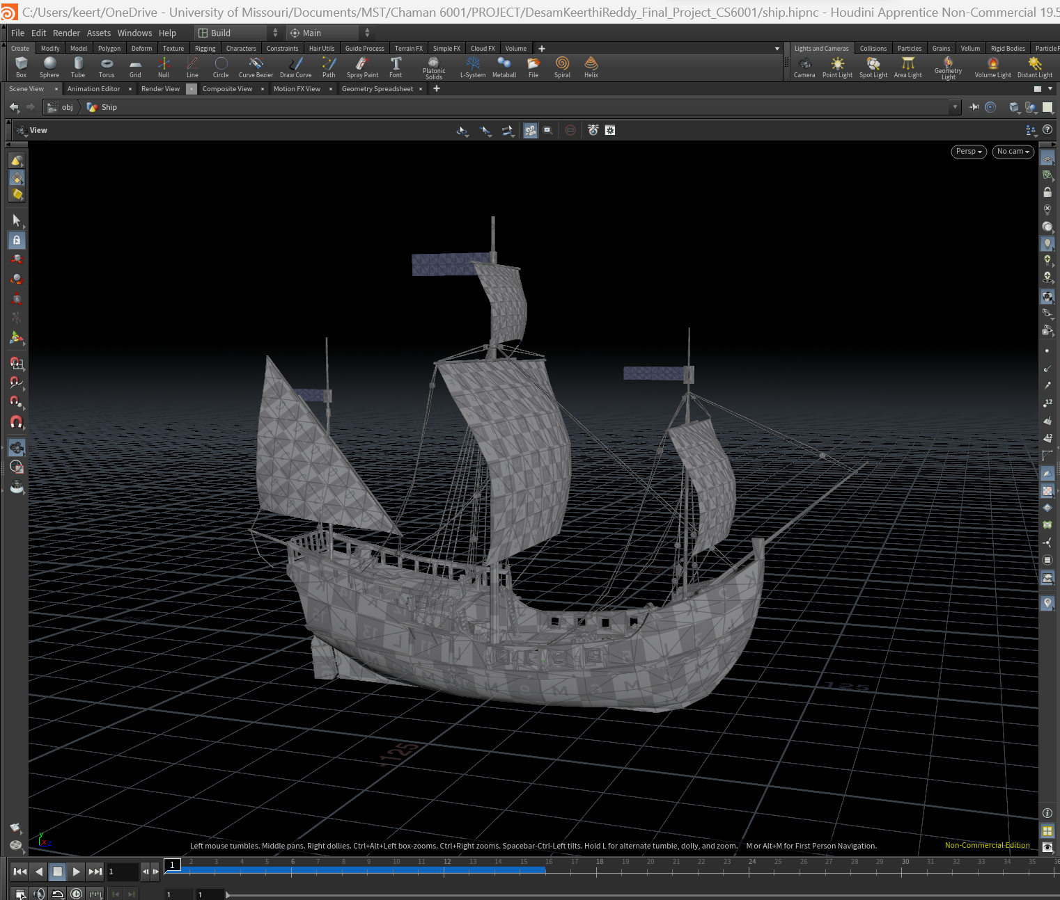

Then I attached the color node and kept it as white so that the ship would be visible. But the ship is larger. To reduce the size I have used the transform node. In the parameter pane of the transform node I have changed the uniform scale to “0.05”. The ship looks as below.

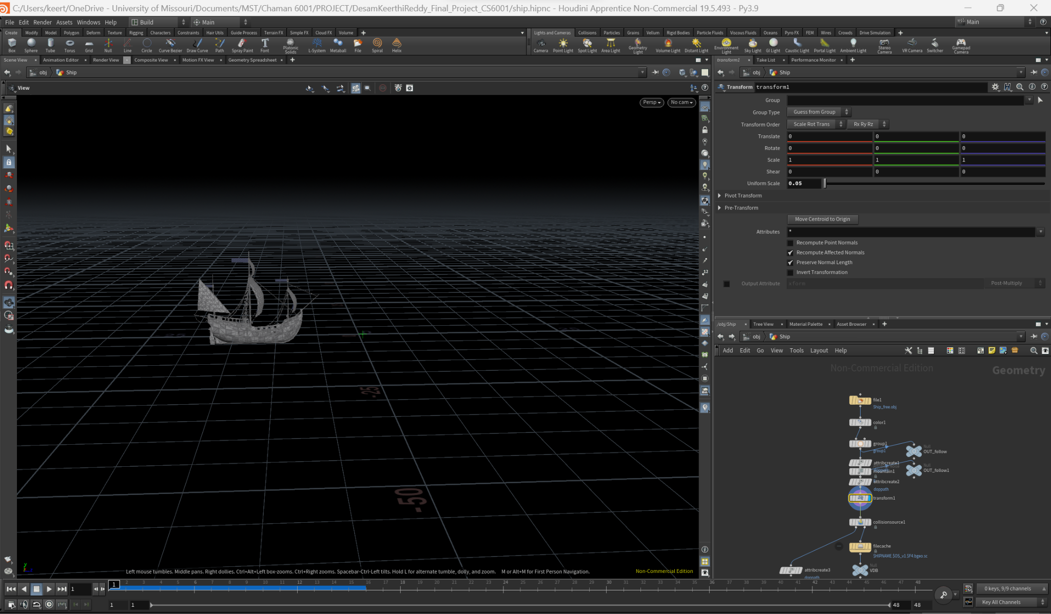

With this step the creation of the ship is done. Next step is to create movement for the ship.

**Step-2:**

To create movement I have used a null node. In the parameter pane of the null node, in the translate parameter, I have changed the z-axis parameter to “$FF/2”. This makes the ship move forward with respect to Frame. But with the waves the ship shakes. So to show the shaking of the ship I have changed both the x-axis and z-axis of the rotate parameters to “sin($FF*5)*1”,”sin($FF*4)*3” respectively. With the above changes the ship will move forward and it also shakes.

At Frame 1:

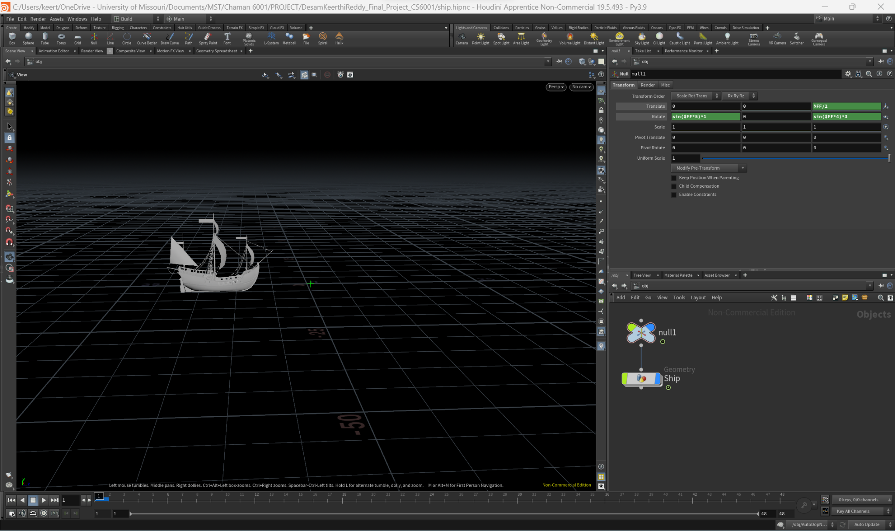

At Frame 20:

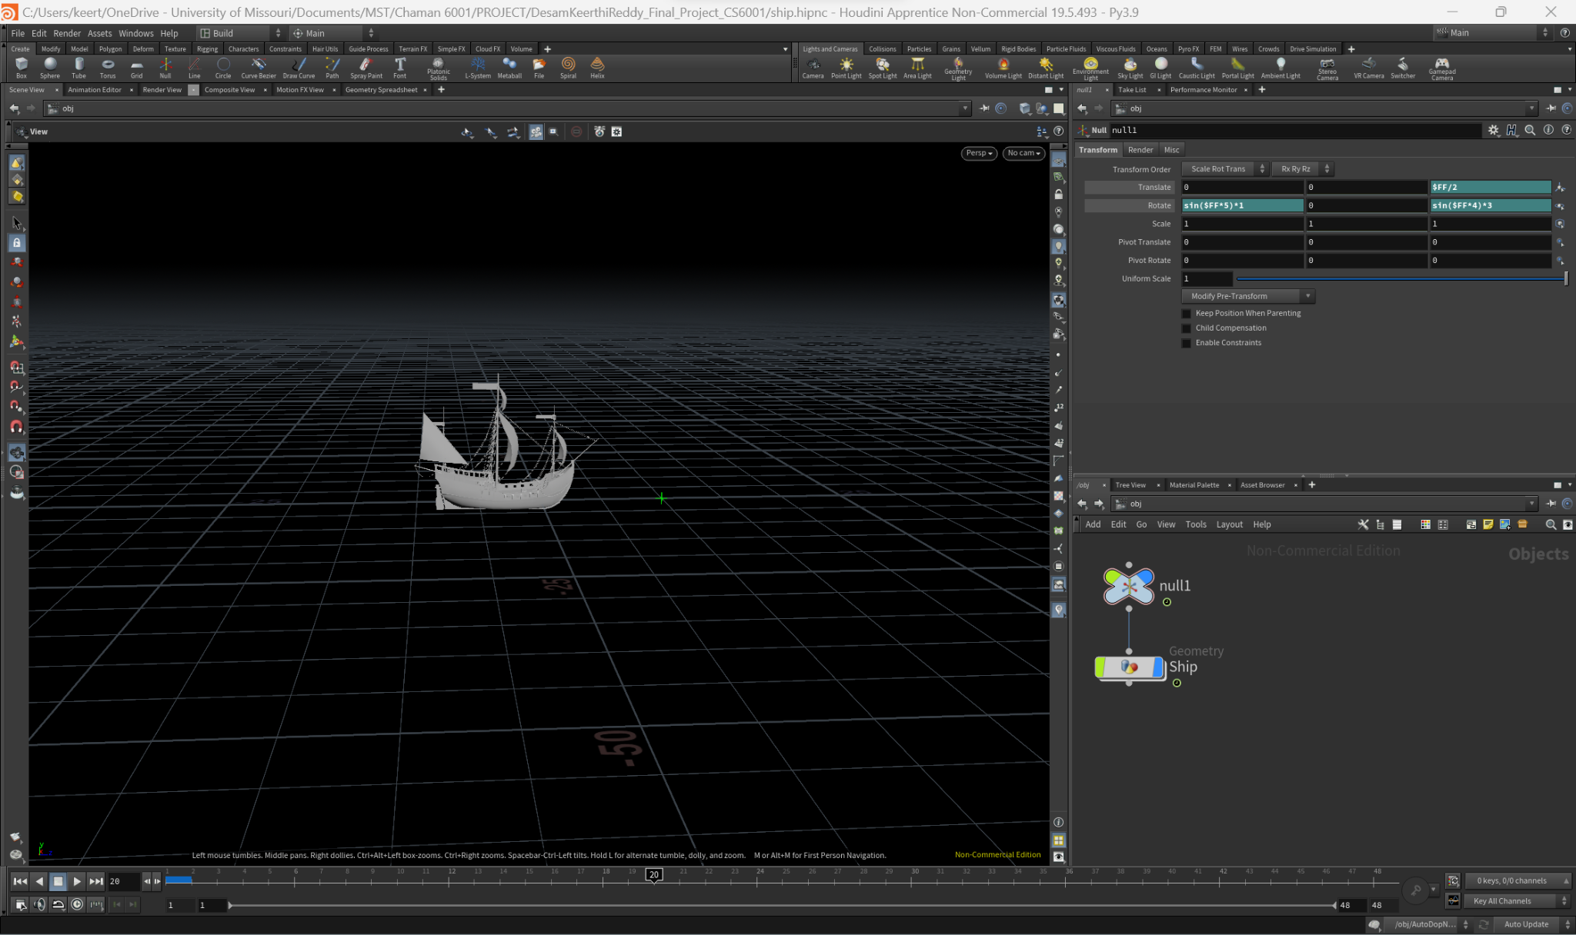

At Frame 30:

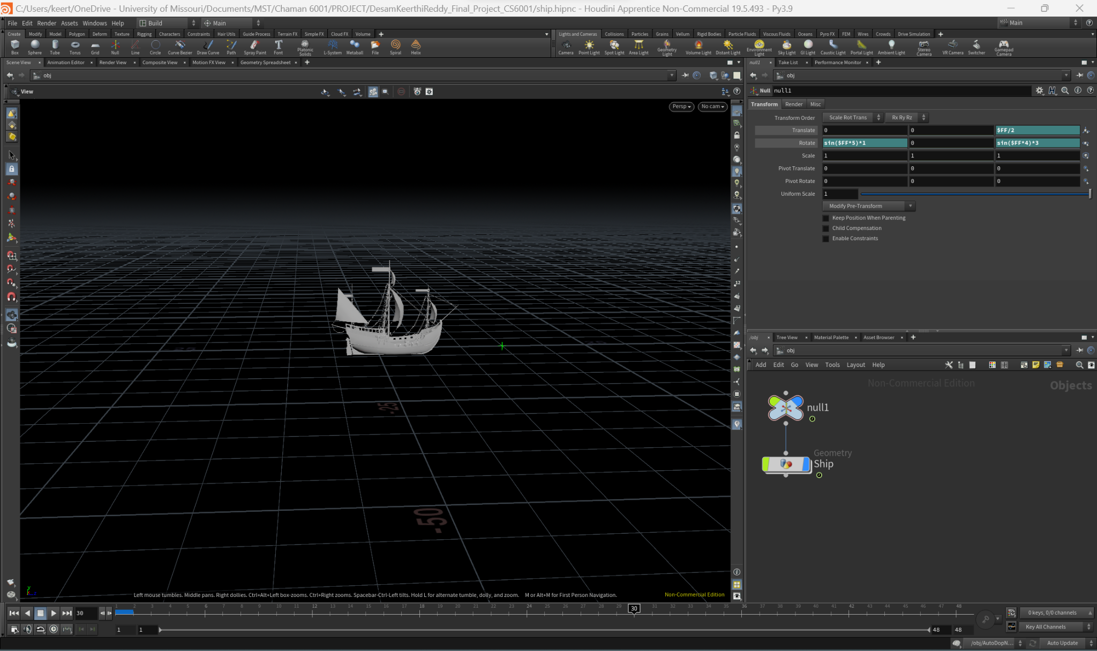

At Frame 48:

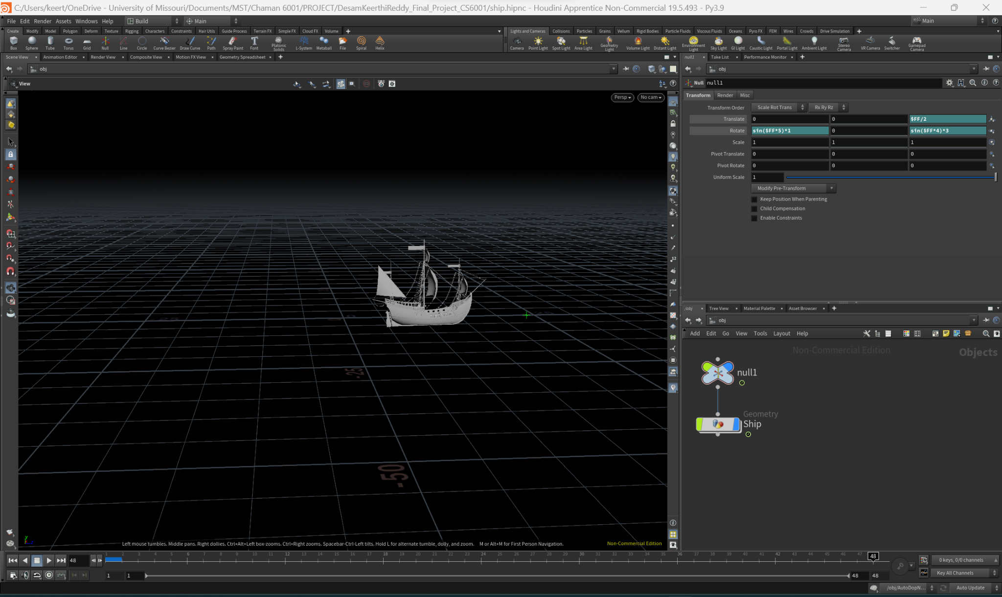

**Step-3:**

Next step is to create an ocean. To create the ocean I have used the flip tank node that is present in the “Particle Fluids” on the top right. Select the flip tank and select the ship so that the ship and flip tank will merge their objects.

After creating the flip tank four nodes are created named as “fliptank_initial”,”fliptank_fluid”,”fliptank_fluidinterior”,”AutoDOPNetwork”.

First go to the fliptank_initial node and select the wave tank. In the parameter pane of wave take, I have changed the sizes to (40,10,40) as x,y,z respectively. And also change the center of y axis to “1”.

To reduce the bandwidth of the ocean I have selected the AutoDOPNetwork, in that i have selected the flip solver. In the parameter pane of the flip solver, change the bandwidth in the NarrowBand to “0.9”.

To create waves along with ship movement, We have a static object in the AutoDOPNetwork. In that go to the collisions and the bullet data and change the geometry representations to “concave”.

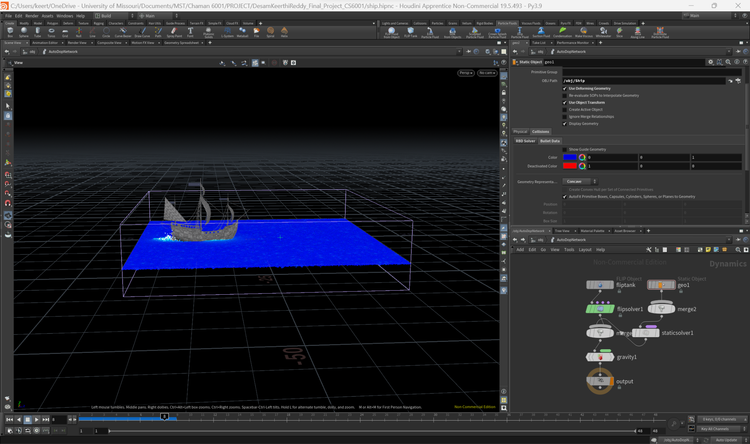

**Step-4:**

Next In order to create ocean with waves we need to do the following:

In the wave tank node in the fliptank_initial, we have an option called initialize, change this to beach tank node. And also attach the ocean spectrum node with the wave tank node. This will create an ocean with waves.

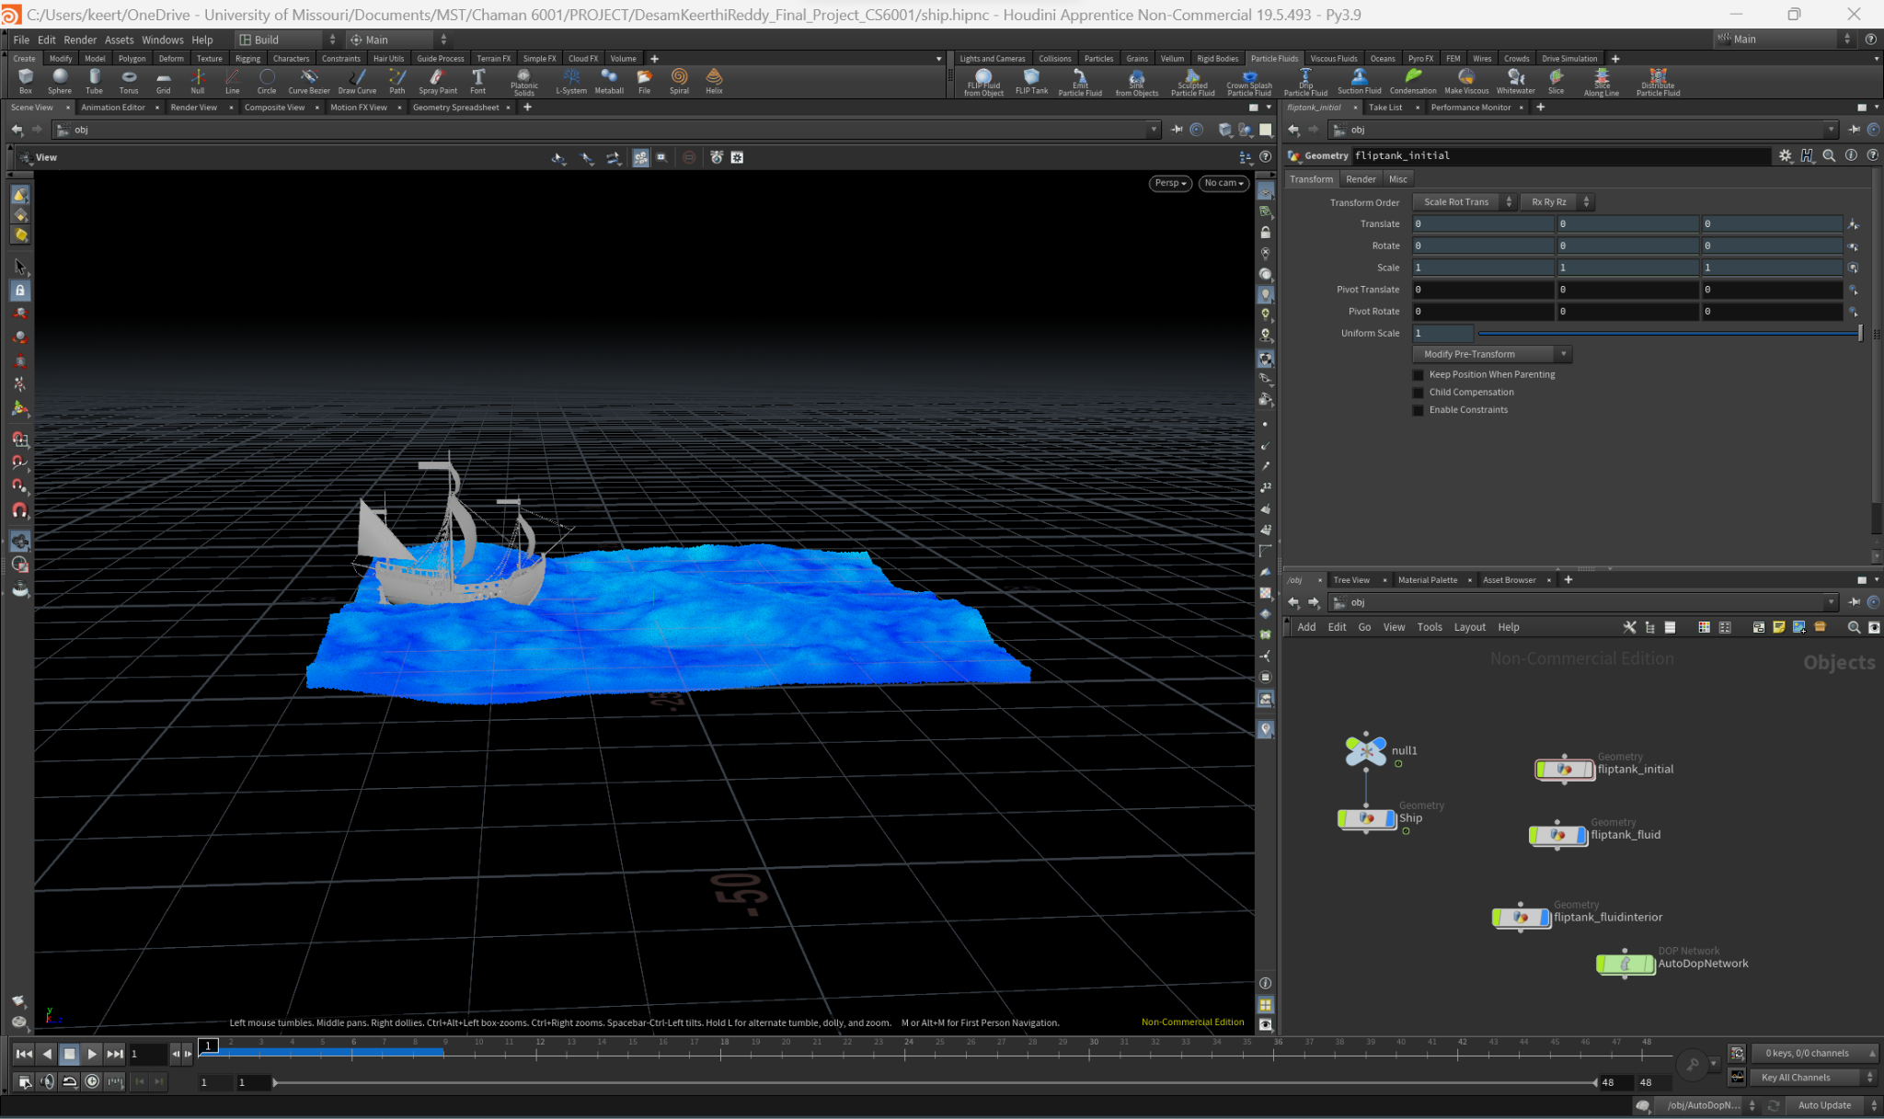

At Frame 1:

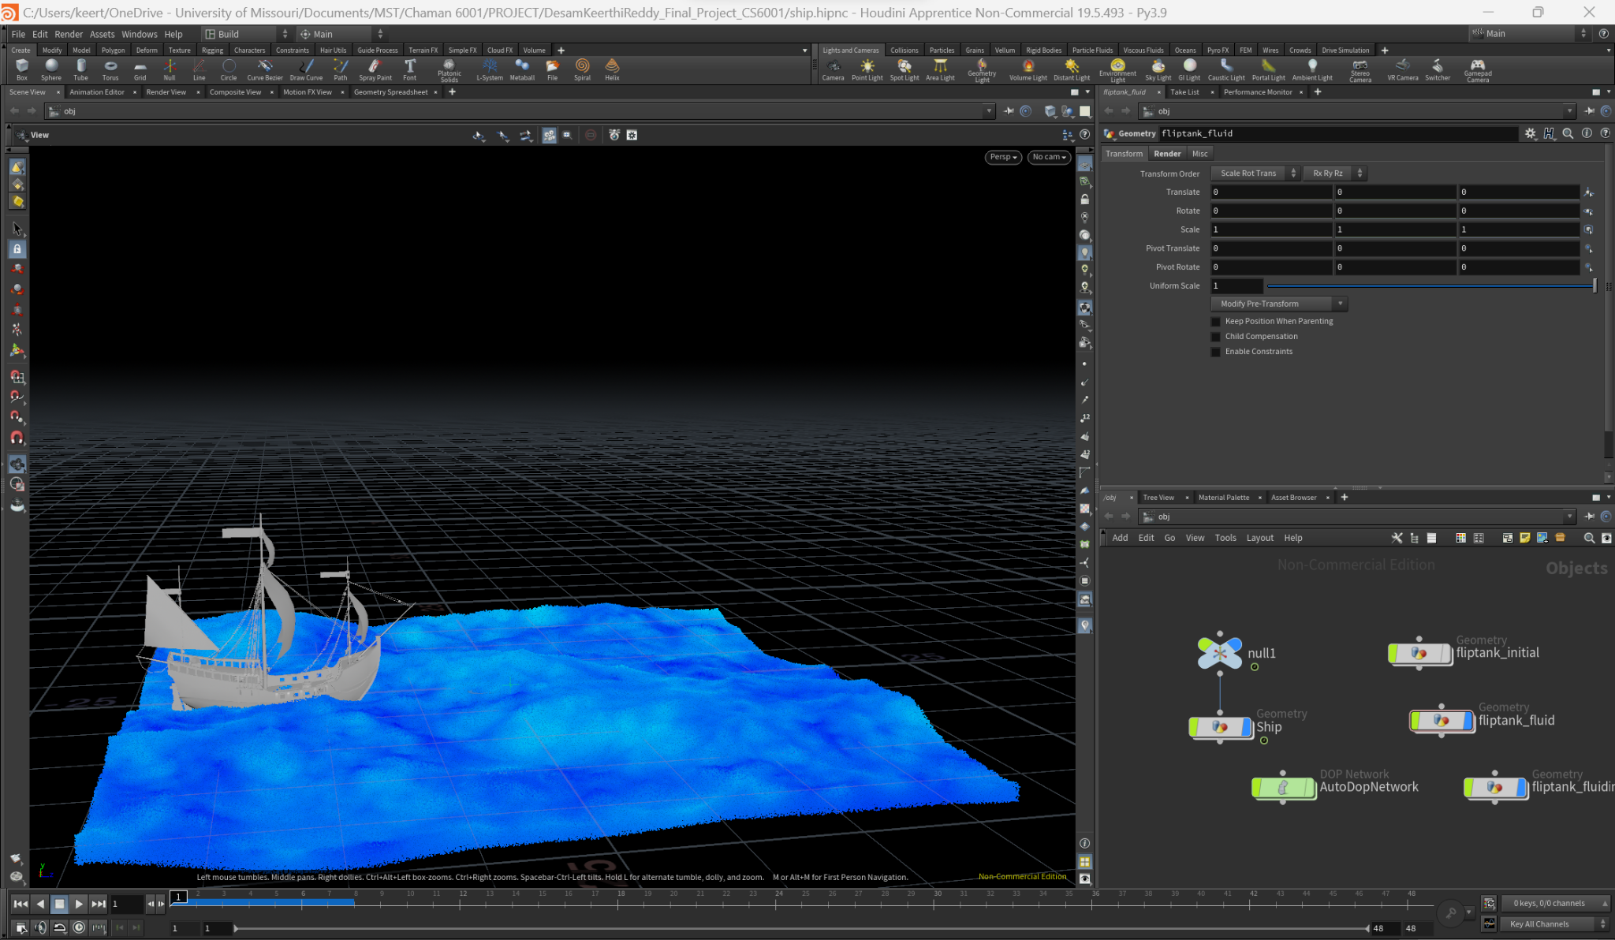

At Frame 20:

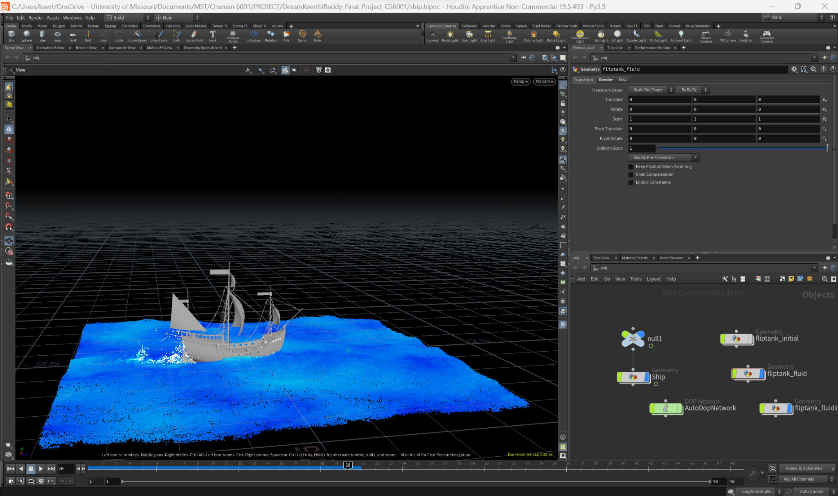

At Frame 30:

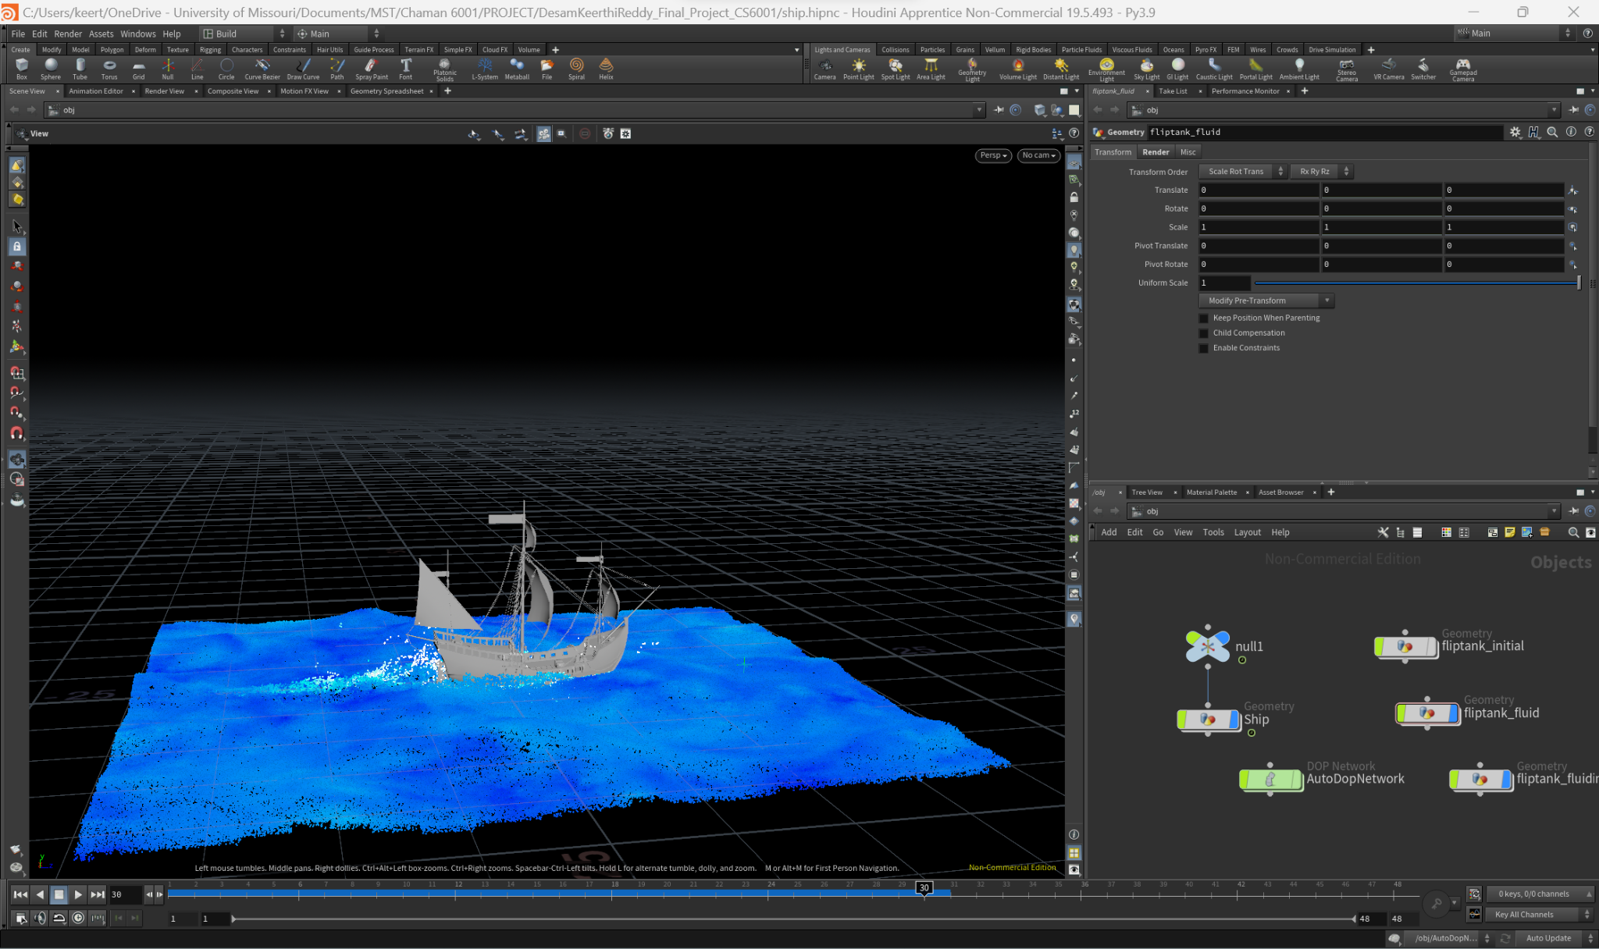

At Frame 45:

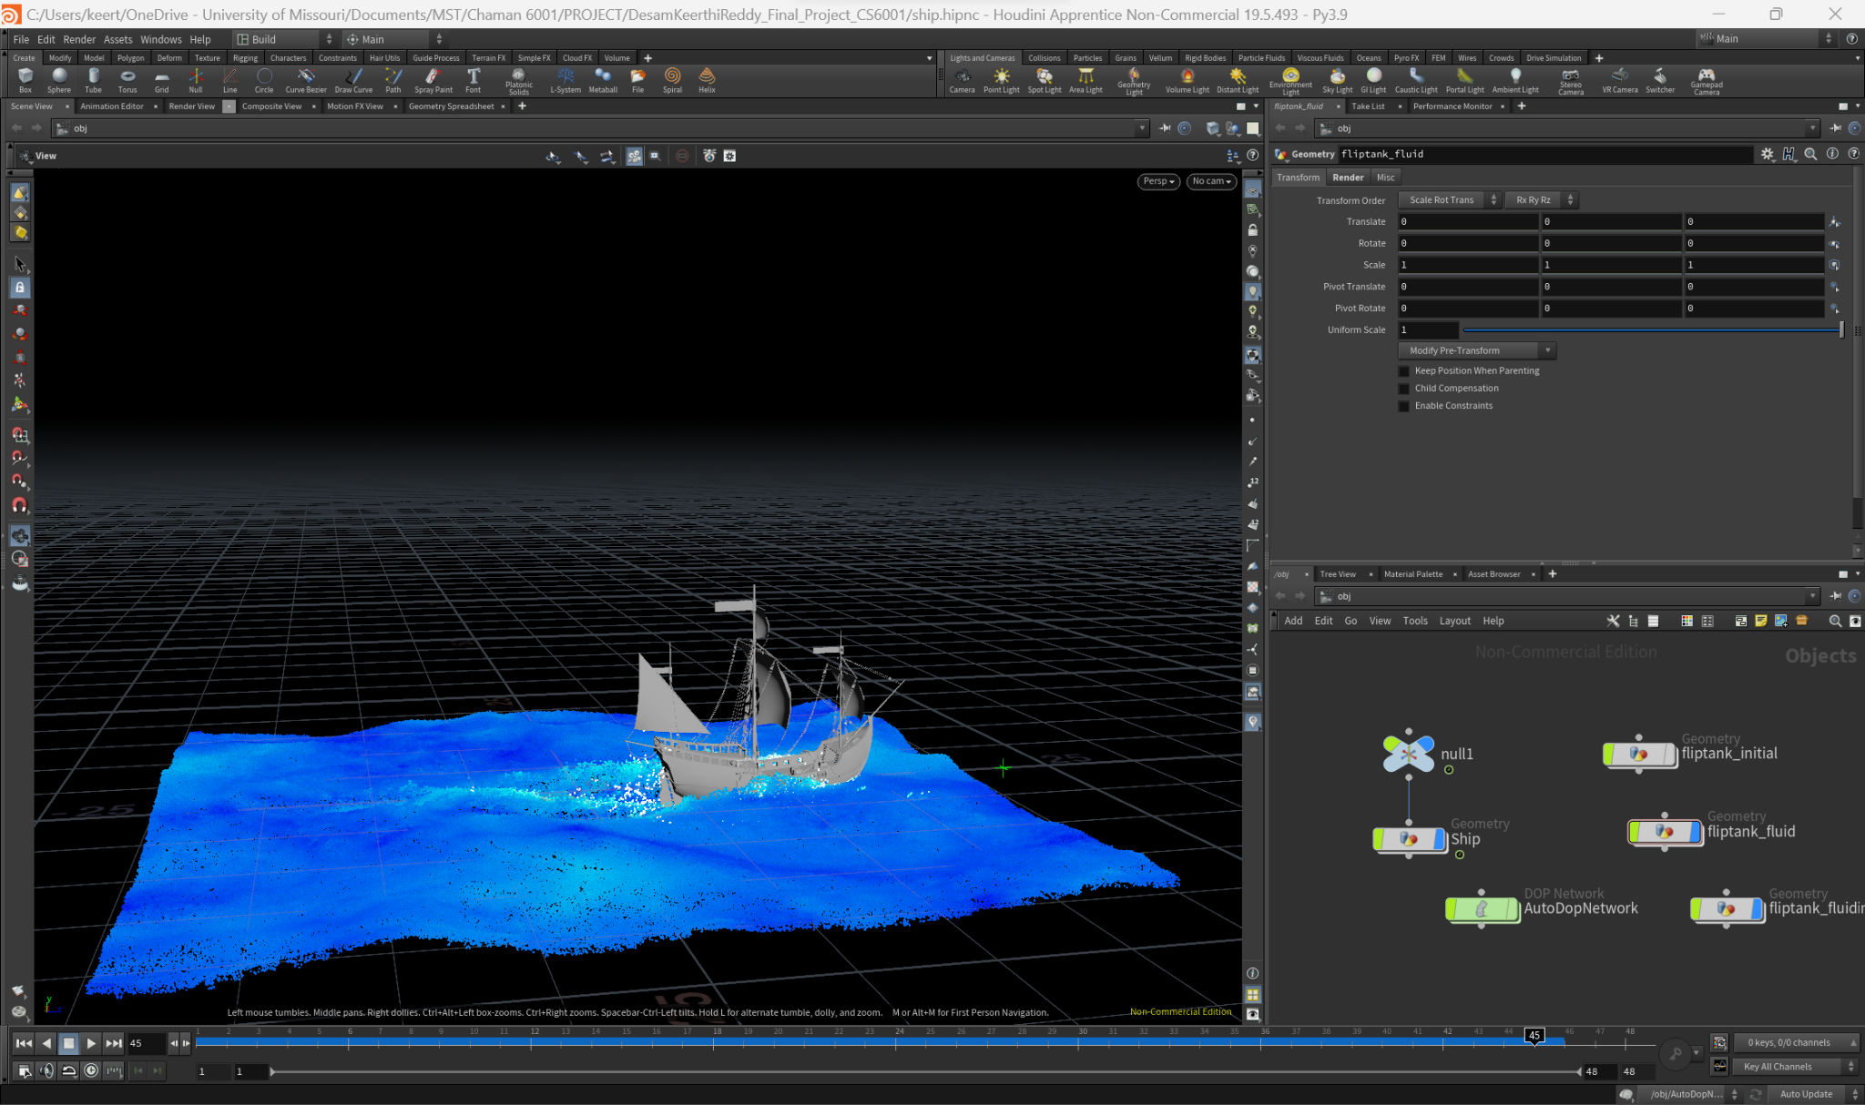

**Conclusion:**

As the ship moves due to the waves, the water in the ocean also starts moving. You can see the movement of waves and water due to the ship.